Fongshan English Village

Shopping Center Pre-Learning Handout

Vocabulary
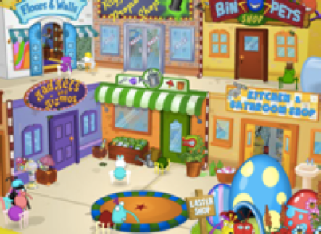 | 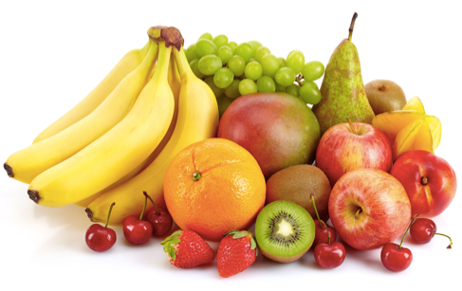 | 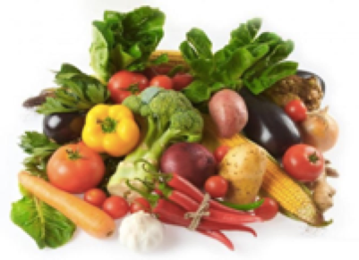 | 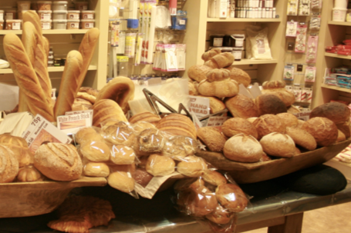
shopping center | fruit | vegetables | bakery
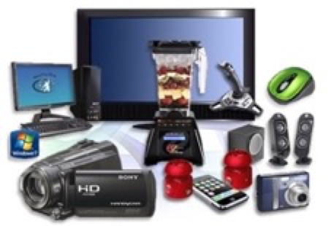 |  | 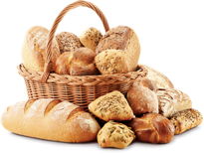 | 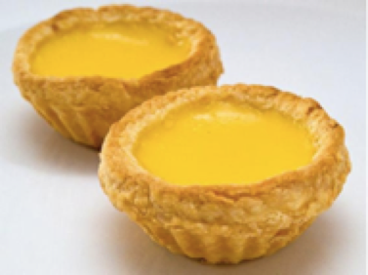
electronics | stationery | bread | egg tarts
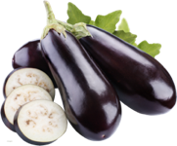 | 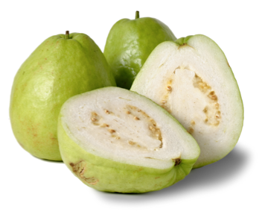 | 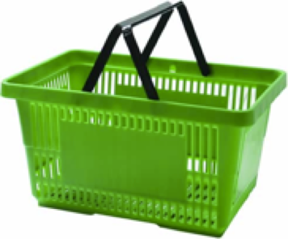
eggplants | guavas | shopping basket | store clerk
 | 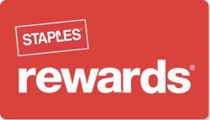  that was easy. ® | 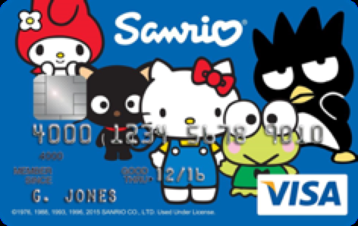 | 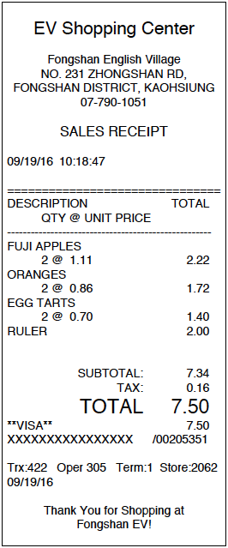
cashier | rewards card | credit card | receipt

Dialogue A  Customer: Excuse me. Where can I find eggplants?  Store Clerk: They’re in the vegetables section over there.  Customer: How about bread?  Store Clerk: They’re in the bakery section.  Customer: Thank you.  Store Clerk: You’re welcome. | Dialogue B  Cashier: Hi. Do you have a rewards card?  Customer: Yes. Here you are.  Cashier: Thank you.  Your total is _______ dollars and _______ cents.  Customer: Here’s my credit card.  Cashier: Here’s your receipt.  Have a nice day!  Customer: You too!

