Fongshan English Village

Bakery Pre-Learning Handout

Vocabulary
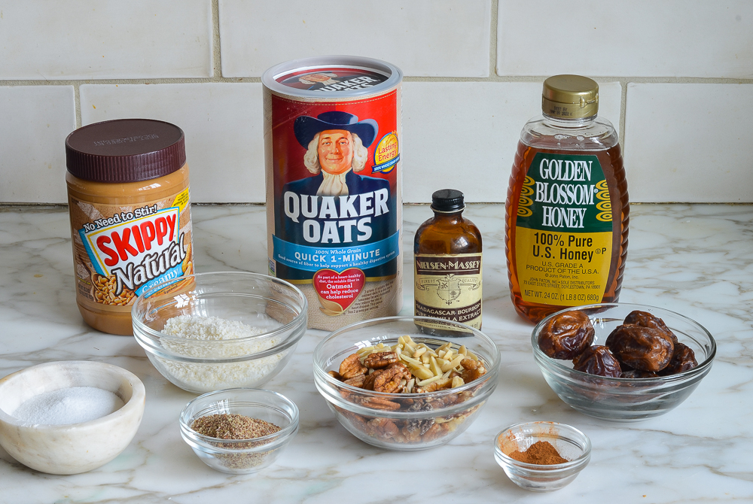 | 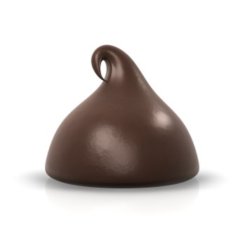 | 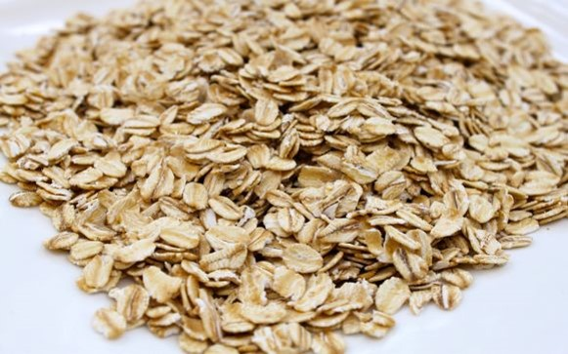 | 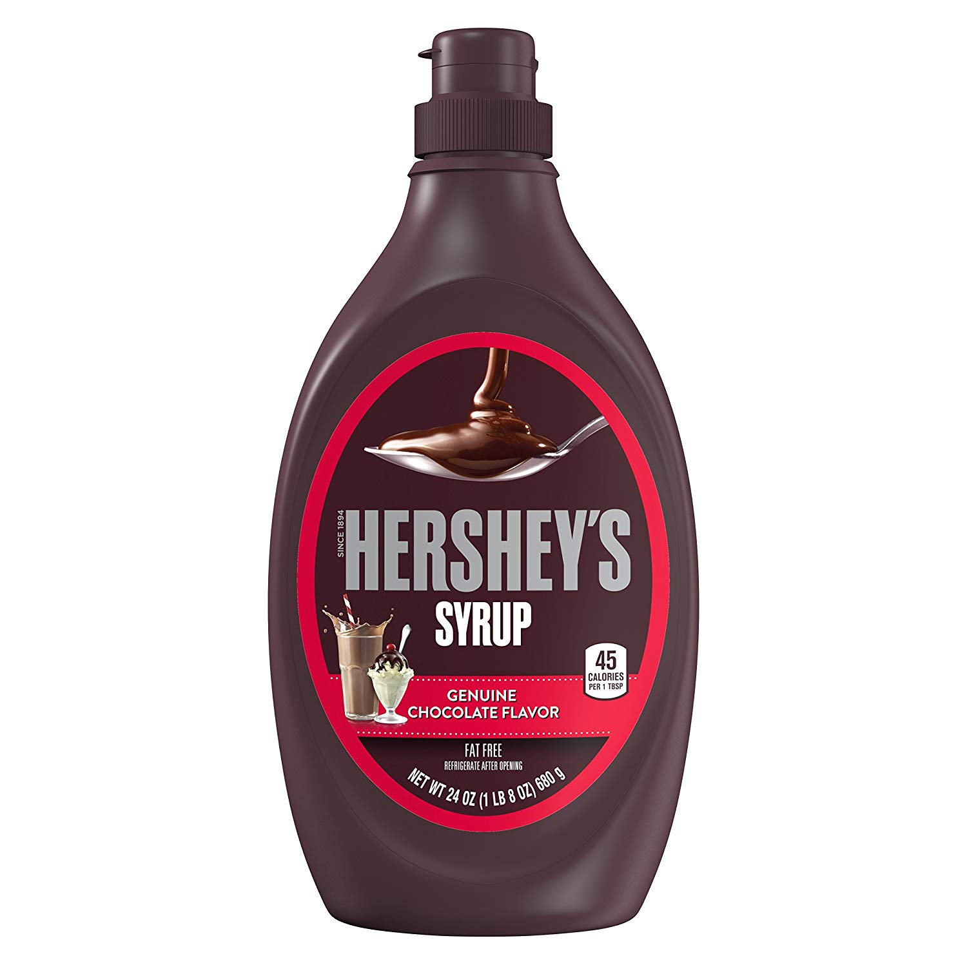
ingredients | chocolate chip | instant oats | chocolate syrup
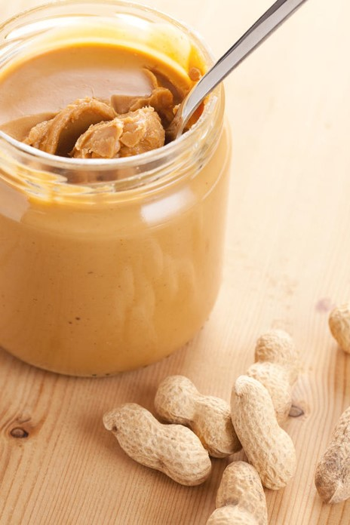 | 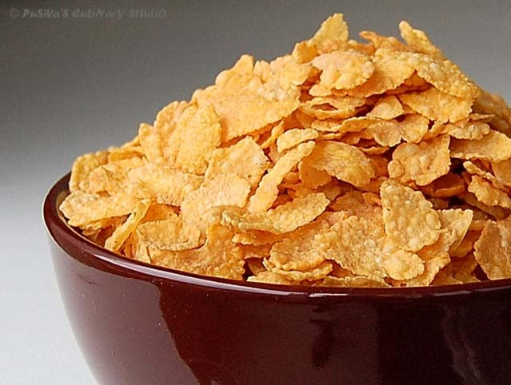 |  | 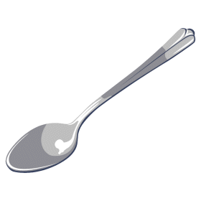
peanut butter | cereal | bowl | spoon
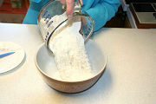 |  |  | 
put | mix | sweep | wipe

Dialogue
Student A: What are we making today?
Student B: We are making no-bake chocolate cookies.

Student A: How does it taste?
Student B: It tastes _________. (yummy, sweet, salty, sour)

